Learning intention: To solve division problems.

Share 6 strawberries between the children. How many do they each get?

Share the 4 apples between the children. How many will they each get?
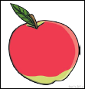

Share the 2 oranges between the children. How many will they each get?
