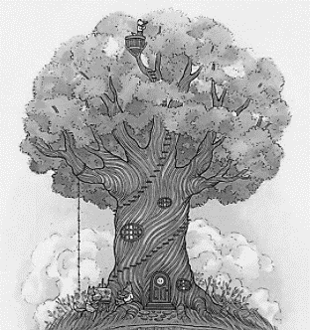 | 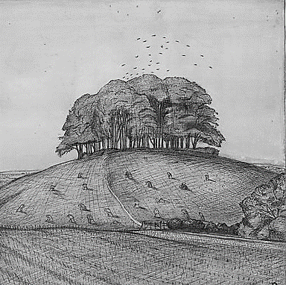
Tree in a wood | Wood on a hill
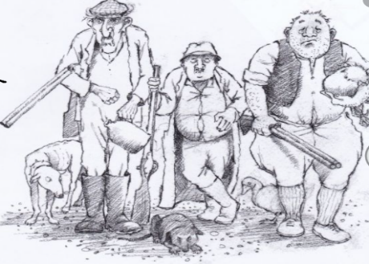 | 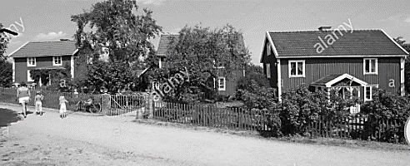
Meet the three farmers | Three farms
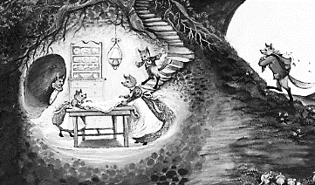 | 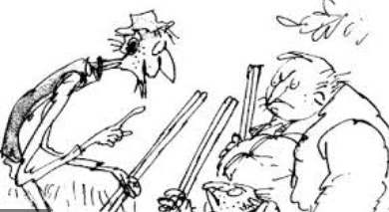
The foxes in their hole | Boggis, Bunce and Bean hide with guns
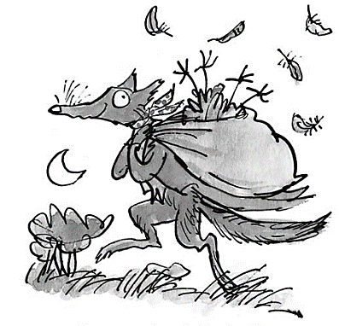 | 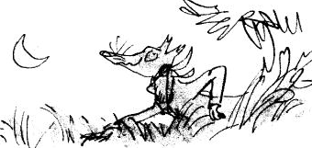
Mr Fox with stolen food | Mr Fox creeping to the farm

Look at the pictures. Can you decide the order they should be in. Discuss with an adult your thoughts and reasons.
If you can draw the pictures in the correct order. You can check again with the powerpoint if you wish.

