Rhyming words
Rhyming words are words that have endings that sound the same e.g. box and fox.
They do not have to be spelt the same, e.g. boot and suit. “oot” and “uit” sound the same when you say them out loud.
- Can you remember any nursery rhymes or favourite songs? Say them and identify the words that rhyme.

- Can you add three more words to these rhyming lists? Make sure the endings sound the same.
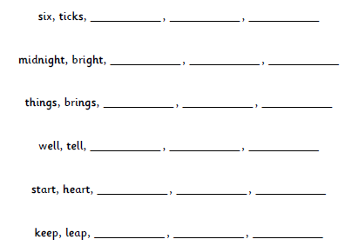

- Can you add any of your own words to the superhero rhyming words?
