Learning Intention: To use Modern Day Vocabulary
Re write the sentences and change the underlined words to modern vocabulary.
Modern means new.

Standing, with her head over the musket.
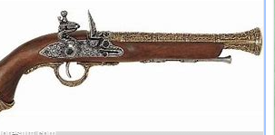

The red coats looked at her and she stood up.
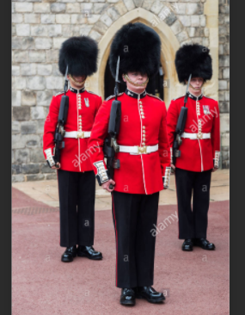

His long sword was twinkling, under the jewelled sky.

