**Amazing Alliteration Activity!**

Remember, **alliteration** is when words start with the same sound.

Like,

**b**lue **b**all 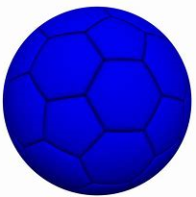 **t**all **t**ree 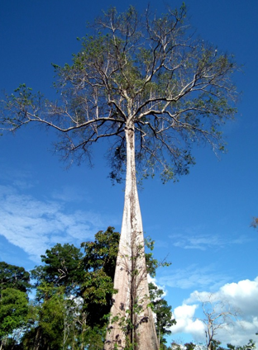 **s**melly **s**ocks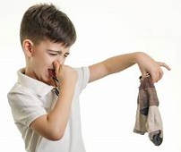

Pick two words to go with each picture.

|  |  |
| --- | --- |
|  |  |
| magic moon | cute |
|  |  |
|  |  |
|  |  |
|  | _________ coat |
|  |  |
|  |  |

Word Bank

Tiger colourful beautiful grass massive mountain slimy moon green butterfly magic cute snake cat