Learning Intention: To work with number bonds.

20 – 1 = 20 – 6 =

20 – 2 = 20 – 7 =

20 – 3 = 20 – 8 =

20 – 4 = 20 – 9 =

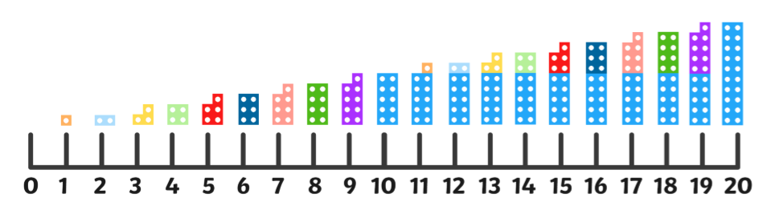
20 – 5 = 20 – 10 =

