Write the Missing Numbers.
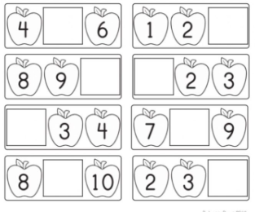

Use these numbers to help you.
0 1 2 3 4 5 6 7 8 9 10

