Year 2 (Tuesday 2.3.21)
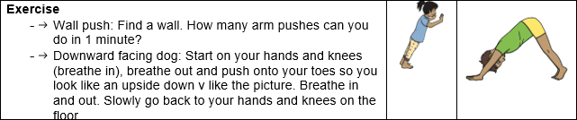
English
Learning intention: to explore possessive apostrophes.

Use the PowerPoint to remind you what possessive apostrophes are. Then change the sentences on the PowerPoint so that the underlined parts include a possessive apostrophe. Challenge: decide for yourself which part of the sentence can be changed to include a possessive apostrophe.

Alternative 1: Use the PowerPoint to remind you what possessive apostrophes are. Then change the sentences on the PowerPoint so that the underlined parts include a possessive apostrophe.
Alternative 2: Use the PowerPoint from yesterday to remind you about apostrophes. Then write the words that you looked at yesterday with apostrophes to show what belongs to them

Spelling: friend school everybody

Handwriting
using the PowerPoint, practise writing ire
Alternative 1: using the PowerPoint, practise writing igh
Alternative 2: using the PowerPoint, practise writing f

Reading
Blue and grey: Re-read the text from yesterday then answer these questions
Orange and yellow: Re-read the story from yesterday then use these pictures to help you retell the story.

Alternative reading
Pink and purple: Use the PowerPoint to read the story ‘Dragon bay’
Red and green: Read the word and match it to the correct picture
Maths
Learning intention: To solve division problems.
Look at the PowerPoint and use this knowledge to answer the division problems on the worksheet.
Alternative 1: Look at Alternative 1 maths PowerPoint and use this to help you answer the division problems on the worksheet.
Alternative 2: Look at Alternative 2 maths PowerPoint and use this to help you answer the division problems on the worksheet.

PHSE Learning intention- To learn about World Wildlife Day.
Look at or listen to the PowerPoint about World Wildlife Day. Tell an adult what you have learnt.

Remember school website is:http://www.moorside.newcastle.sch.uk/website
If stuck or want to send completed work then email linda.hall@moorside.newcastle.sch.uk

