Maths Learning intention: To revisit properties of shapes.
Shape quiz
- Circle the 3D shapes. Bonus points if you can name them!

- Name the 2D shape with only one side.
- Name the 3D shape with two faces that are circles.
- Name the 2D shape that has exactly five vertices.
- Name the 3D shape that has exactly five vertices.
- I am thinking of a shape. It is 3D. It has at least one square face. Which of these shapes could it be?

- How many hexagons can you see? Hint: think about how many sides a hexagon has.
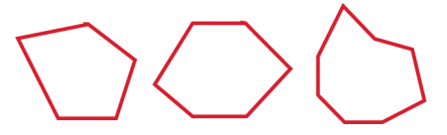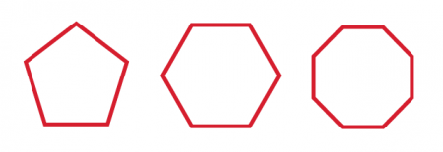
- Which shape is the odd one out? How do you know?
- I am thinking of a shape. It is 2D. It has less than 4 vertices. Which of these shapes could it be?
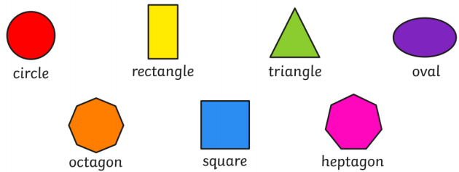

- How many 3D shapes can you think of that have a curved face?

