Geography alternative- Develop key vocabulary

Draw a picture to match each of the words below. Use the PowerPoint to help you read the words if you need it. I have done one for you

Weather | Rain
Wind | Temperature
 | 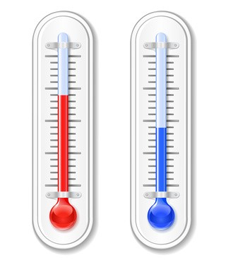
Cloud | Earth
Sun | Snow

