**Thursday 28th January – Alternative Maths**

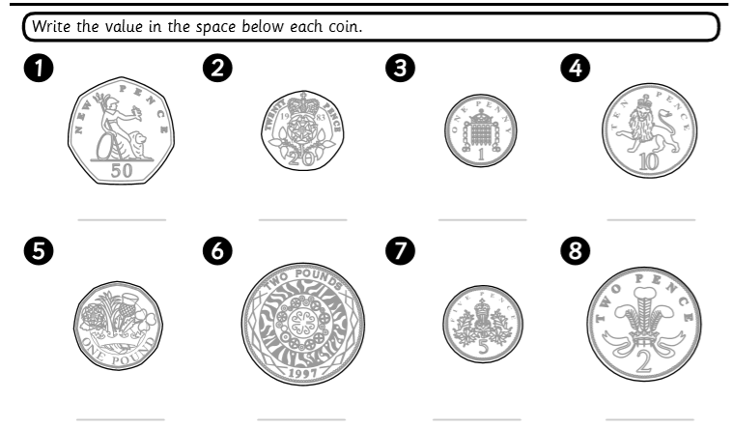

1p 2p 5p 10p 20p 50p £1 £2

