Year 2 (Friday 12.2.21)
Exercise: Pick two of the yoga poses (stretches) below to practise. How long can you stay in the same position without getting wobbly? See if you can beat your time!
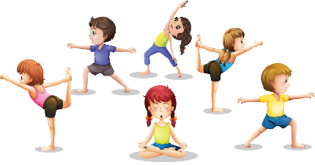
English
Learning intention: To show understanding of a text.

Look at the quiz sheet. Can you use your knowledge of the traditional tale ‘Hansel and Gretel’ to answer the questions?

Alternative quiz: Listen to the teacher read the quiz questions, or ask an adult to read the questions on the PowerPoint. What can you remember about the story of ‘Hansel and Gretel?

Spelling: half money Christmas

Handwriting
Practise ‘are’ using the PowerPoint. Alternative 1: practise ‘or’ using the PowerPoint. Alternative 2: practise ‘p’ using the PowerPoint.

Reading
Blue and grey: Read the clues to complete the crossword.
Orange and yellow: Read the ‘au’ words. Tick the real words and cross the nonsense words.

Alternative reading
Pink and purple: Circle the word to match the picture.
Red and green: Match the caption to the picture
Maths
Learning intention: To consolidate number work.
Use the PowerPoint to complete the number quiz. Then can you complete the worksheet ‘snail maths’.

Alternative quiz: Listen to the teacher read the quiz questions, or ask an adult to read the questions on the PowerPoint. Then complete the snail maths sheet.

Chinese New Year
Learning intention: To explore the story of Chinese New Year.

Look at the PowerPoint and discuss the story of Chinese New Year. You could create a story map of the story and use this to retell it. Try the worksheet using pictures to identify words linked to Chinese New Year.

Alternative 1: Look at the PowerPoint and discuss the story with an adult. Talk about the questions at the end of the PowerPoint. Draw and label some of the animals from the story.
Remember school website is:http://www.moorside.newcastle.sch.uk/website
If stuck or want to send completed work then email linda.hall@moorside.newcastle.sch.uk

