27.1.21 Alternative English
Which words best describe the character? You could ask an adult to help you read the word. Tick them
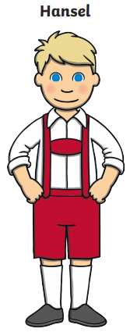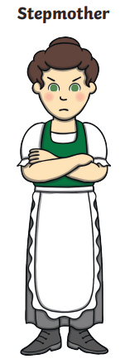
happy | friendly
caring | wicked
short | small
old | grumpy
clever
happy | friendly
caring | wicked
short | small
old | grumpy
clever

