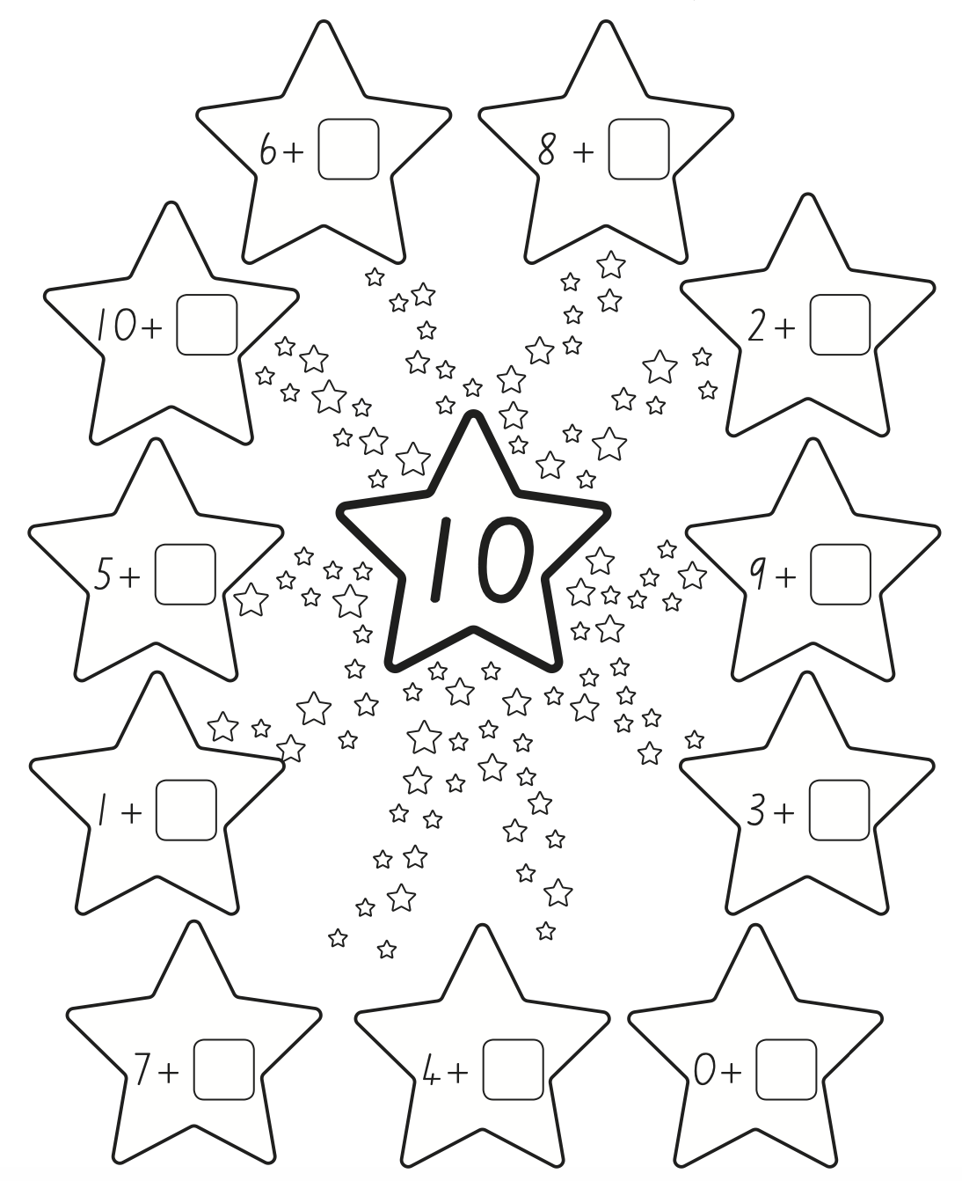
Can you complete the number sentences so that each star equals 10? 