Amazing Alliteration Activity!

Alliteration - a group of words in a sentence, which have the same consonant sound at the start of the word.
Task 1.
Can you remember what the consonants are?
All letters are either a vowel or a consonant. If you know the vowels then you know the consonants.
Circle the vowels and underline the consonants.
a b c d e f g h i j k l m n o p q r s t u v w x y z

Task 2
Look at yesterday’s PowerPoint to remind yourself what alliteration is. Watch the BBC Bitesize Video
https://www.bbc.co.uk/bitesize/articles/zc3v6g8
Watch the video of poet Joseph Coelho again to hear alliteration being used. Start watching at 1 minute and 18 seconds and finish at around 3 minutes and 17 seconds.

Make a list of alliterative words that could go with each picture. Then use those words to write an exciting, scary or funny, alliterative sentence.
One has been done for you as an example.
Snake  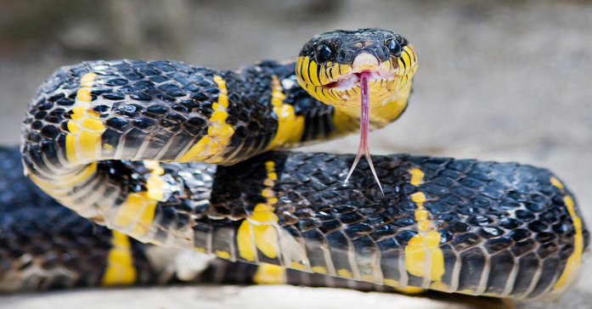 | Vocabulary  Slithers, silently smooth scaly slowly slippery scorching sand sunburned
Sentence
The slippery snake slides silently over the scorched, sunburned sand.
Mountain | Vocabulary
____________________________________________________________________________________________________________________________________________________________________________________________________________________________________________________________________
Castle | Vocabulary
__________________________________________________________________________________________________________________________________________________________________________________________________________________________________________________________________
Dragon  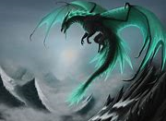 |  | Vocabulary
____________________________________________________________________________________________________________________________________________________________________________________________________________________________________________________________________

