English – Writing Commands

Give commands to the animals telling them what they are not allowed to do.
Here are some imperative verbs to help you: can’t don’t

Example:

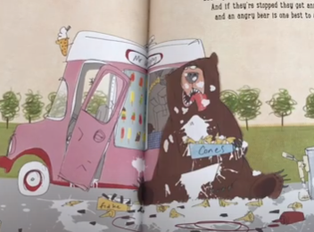
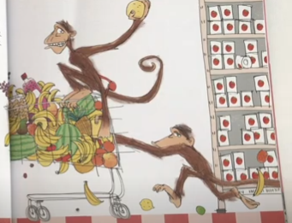
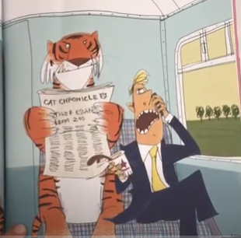
Don’t let a tiger on the train.

