The Three farmers descriptions
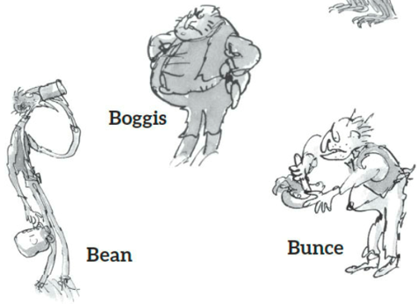

Which word would go with which farmer? One word from each group goes with each farmer. Look at the pictures above. You can also listen to the first two slides of the story again.
Group 1 | Group 2 | Group 3 | Group 4
Thin  Short  fat | miserable  drinking  tall | Chicken farmer  Duck and goose farmer  Turkey and apple farmer | Ate no food  Ate doughnuts  Ate three chickens at every meal

Looking at the pictures if you can find any other words to describe the farmers add them too.
Boggis | Bunce | Bean

