22.1.21

To evaluate art work
Have a look at the art work below. Could you select one that you would like to evaluate?
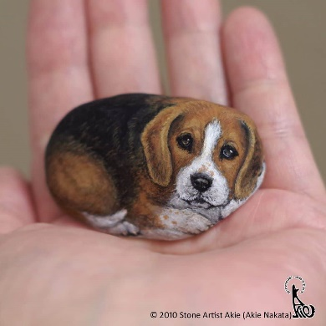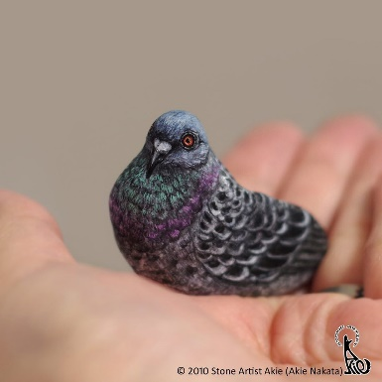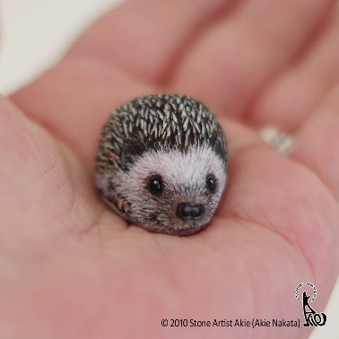
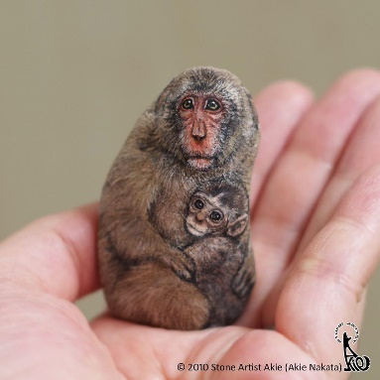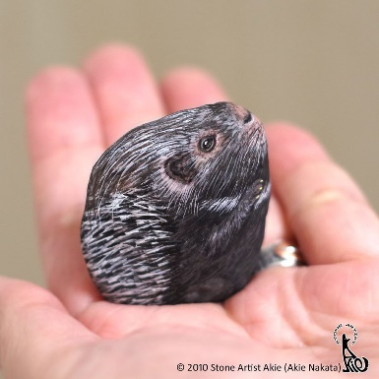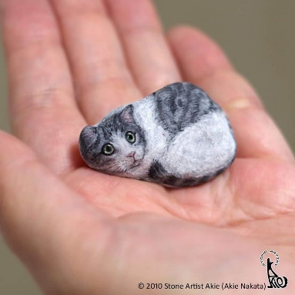

What has the stone been created into?

How do you think Akie Nakita achieved this? Can you see the individual brush marks? What colours have been used?

What do you like about the art work?

Would you change anything about the art work?

Could you draw the outline of your own stone below?

Now, could you think about what you could create on it? Use your imagination and sketching skills to sketch a chosen animal , just like Akie Nakata.

