28.1.21- Alternative English

You have been looking at pictures from the Hansel and Gretel story. These are pictures from a different version of the book. Ask an adult to read the labels to you then match them to the correct picture.

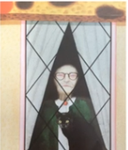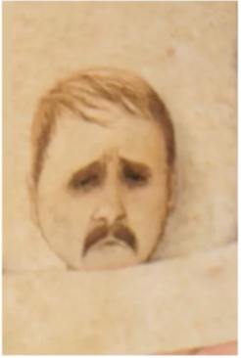
Hansel

witch

treasure

woodcutter

Gretel

house



