Alternative 2 Maths
Learning intention: To calculate halves and quarters of amounts
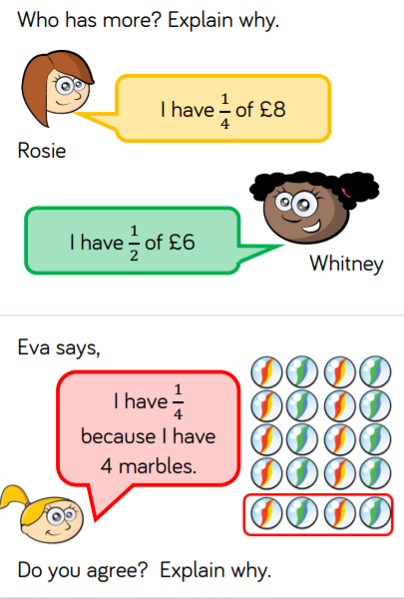
½ of 8 =

¼ of 12 =

½ of 10 =

½ of 16 =
¼ of 20 =

½ of 14 =

½ of 18 =

¼ of 16 =

