Maths
- Sarah and Max are making numbers.
Sarah’s numbers
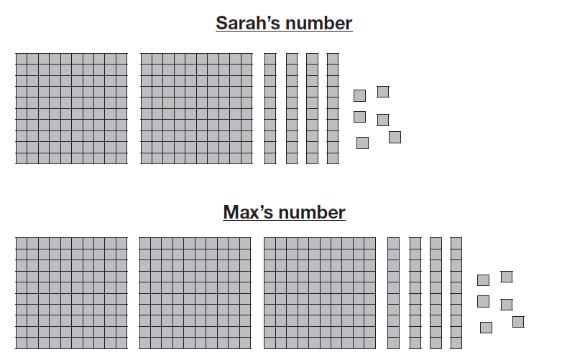

What is Sarah’s number?
What is the difference between Sarah and Max’s number?

- Here is a part- whole model
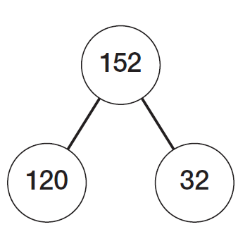
Use the model to complete the number sentences:
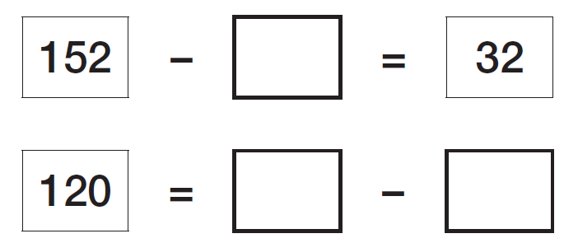

- Footballs come in boxes of 4.
How many footballs are in 6 boxes?______ balls

Mr Johnson needs 36 footballs. How many should he buy? _____ boxes

- Lily has £5 to buy her lunch. She uses these coins
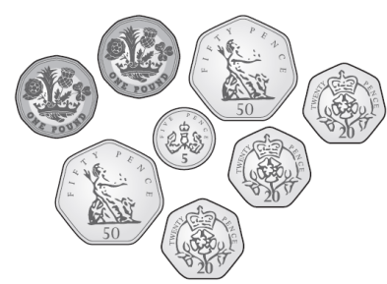
How much money does Lily have left?

- Tom places a number on the number line.
Is Tom correct? Explain why.

- Complete the missing numbers:

- Work out the perimeter of these shapes:
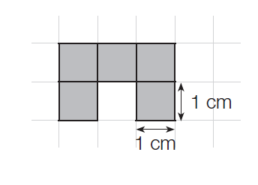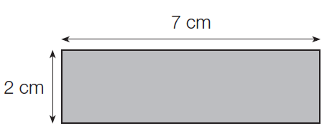

_______ cm ________cm

- Jack is counting up in multiples of 6 from 0. He records his numbers on a number track
Sam is counting up in multiples of 7 from 0. He records his numbers on a number track
In whose track will the number 42 appear first?

- A toy shop has 2,328 games in stock.
They receive 981 more games.
They sell 1,453 games.
How many games are left?

- Mrs Hyde bakes 180 cookies. She sells them in boxes of 10. Each box costs £4. How much money does she make in total?

- Complete the missing digits.

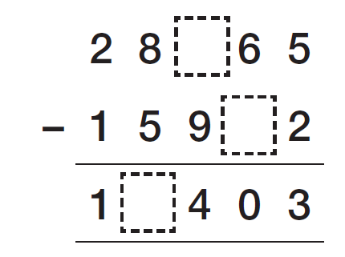

- Class 1 and class 2 have a total of 675 points. Class 1 has double the number of points that Class 2 have. How many house points do Class 2 have?

- Write each number in it’s correct place on the diagram

4 8 16 32 40 48
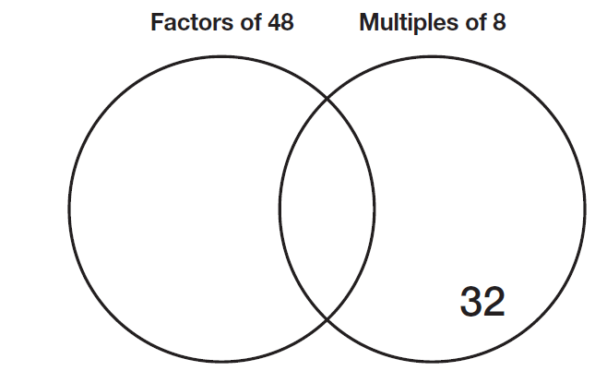

- In total there are 43,472 adults at a football match. There are 4,300 more women than men at a match. How many men are at the match?

