Learning intention: To identify and describe properties of 3D shapes, including the number of edges, vertices and faces.

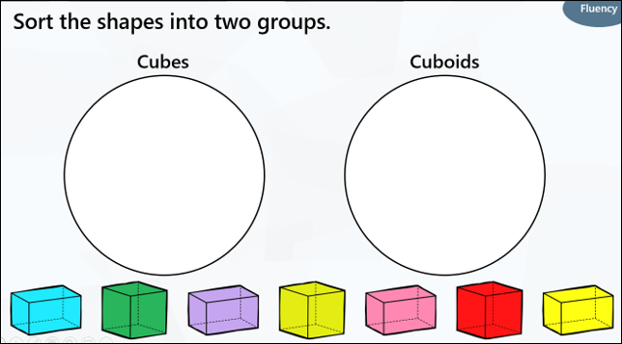 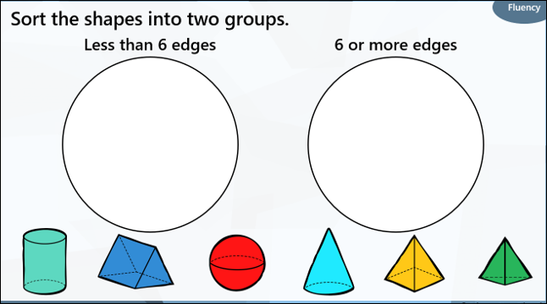

Try this challenge

