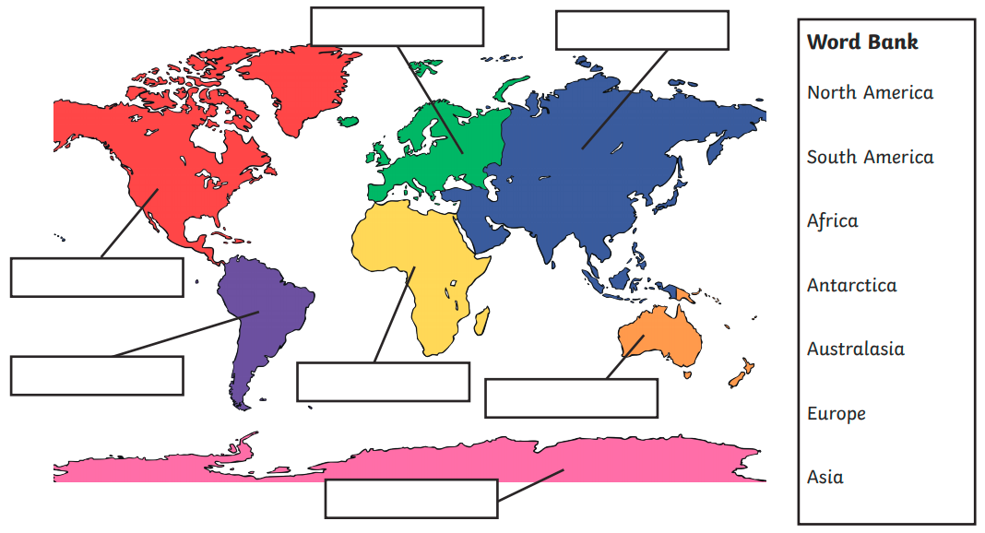
Alternative learning Geography - The seven continents of the world

