To be able to explain the features of fractions (alternative)

Use the information in the PowerPoint to help you.

- Draw a little tick next to all the unit fractions and a little cross next to the non-unit fractions
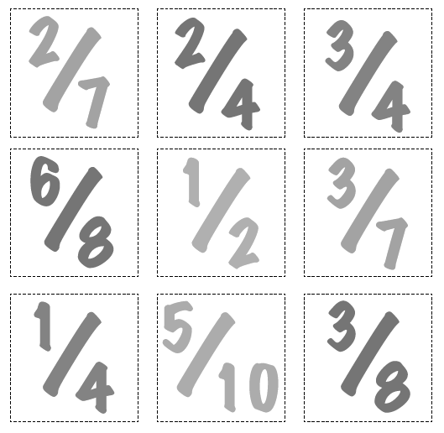
- Explain the different between a unit and non-unit fraction.

…………………………………………………………………..

…………………………………………………………………..

- Draw a circle around the numerators and a square around the denominators.
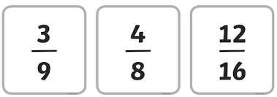

- Explain the different between a unit and non-unit fraction.

…………………………………………………………………..

…………………………………………………………………..

