Art

Learning intention: to evaluate a piece of art.

You are going to be an art critic and evaluate a piece of art.

What did you see?

What did you like?

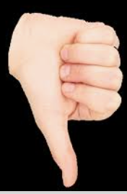 What did you not like?