English

Draw a verb in each sentence stem to make it complete. Use the verb bank sheet to help you if you need it.

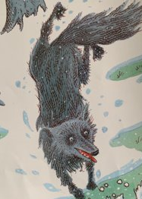
The
can
.
The
can
.

.

