Alternative Learning English - Horrid Henry and Moody Meg
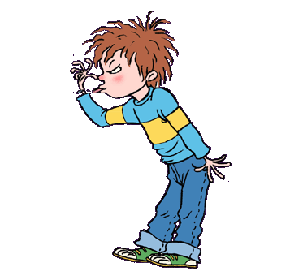
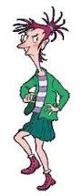

“I’m Captain Hook!”
“No, I’m Captain Hook!”
“I’m Captain Hook,” said Horrid Henry.
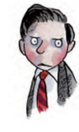
“I’m Captain Hook” said Moody Meg.
They glared at each other. “It’s my hook,” said Moody Meg.
Moody Meg lived next door. She did not like Horrid Henry, and Horrid Henry did not like her. But when Rude Ralph was busy, Clever Clare had flu, and Sour Susan was her enemy, Meg would quickly jump over the wall to play with Henry.
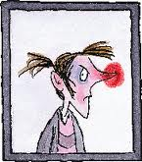
“It’s my turn to be Hook now,” said Perfect Peter. “I’ve been the prisoner for such a long time.”
“Prisoner, be quiet! Said Henry.
“Prisoner, walk the plank!” said Meg.
“But I’ve walked the plank fourteen times already,” said Peter. “Please can I be Hook now?”
“No!” said Moody Meg. “Now out of my way, worm!” And she dashed across the deck, madly waving her hook and clutching her shiny sword and dagger. She was wearing her eye patch and a skull and crossbones hat.
Henry had a stick. This was why Henry played with Meg. But Henry had to do terrible things before playing with Meg’s amazing swords. Sometimes he had to play ‘Mums and Dads’ with her. Worst of all (please don’t tell anyone), sometimes he had to be the silly baby.
Henry never knew what Meg would do. When he put a spider on her arm, Meg laughed. When he pulled her hair, Meg pulled his harder. When Henry screamed, Meg would scream louder. Or she would sing. Sometimes Meg was fun. But most of the time she was a moody old grouch.

