26.1.21
To retrieve information from a text
To draw inference from a text

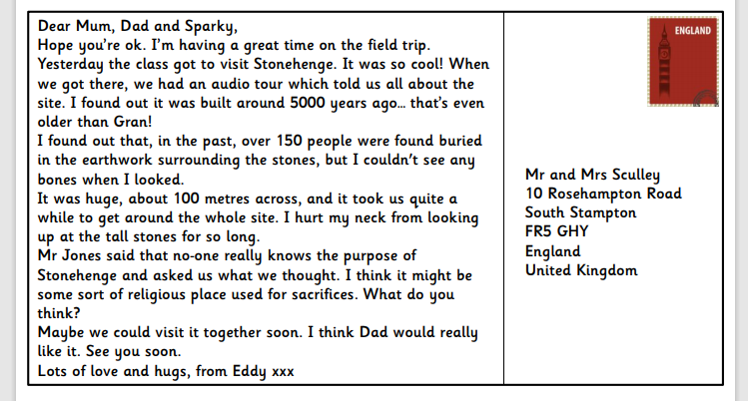

What do you think the purpose of a postcard is?

Who do you think Sparky is?

How long ago was Stonehenge built?

Who do you think Mr Jones is?

How does Eddy feel about his visit to Stonehenge? Use evidence from the text to support your answer.

Informal writing like postcards often use humour. Can you find an example of this in the text? How old do you think Eddy is? Why do you think this?

