English alternative- Chapter 6

Read chapter 6 of Fantastic Mr Fox then complete the task below by filling in the missing words. Use the words underneath to help you.

Imagine that you are one of the farmers, you can choose which one!

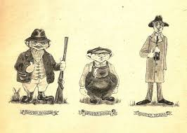

A police officer arrives and sees you using your diggers.
What can you tell him to stop him arresting you for destroying the environment?

We are trying to catch _________________who has been ________________our ________________ , ______________, _______________ and _______________. His house is underneath this huge ________ . We have tried ____________ him out with shovels but he ________________. We are sure he won’t _________________ from us now we are using these mechanical _______________.

___________________________________________________________________

Diggers Mr Fox ducks digging tree geese turkeys escaped escape stealing chickens

