Look at these poems from yesterday PowerPoint.
Some of the rhyming words are missing. Remember rhyming words are words that sound the same. Can you say the missing word?
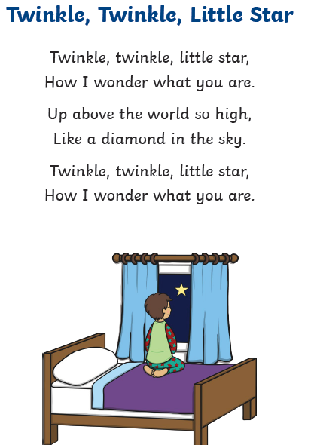
These are the missing words, decide which one goes in the correct place.
star
are

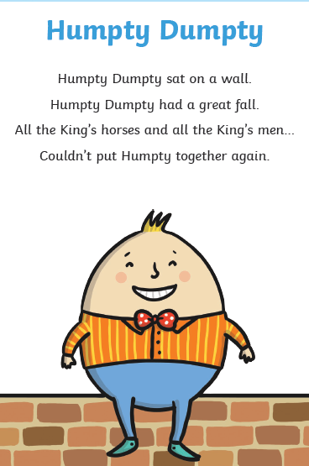
These are the missing words, decide which one goes in the correct place.
men
wall

