English – Writing Commands

Give commands to the animals telling them what they are not allowed to do. If you can, have a go at writing the command next to the picture.
Here are some imperative verbs to help you: can’t don’t

Example:

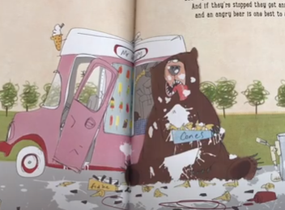
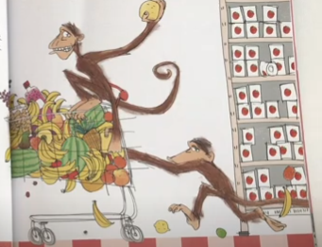
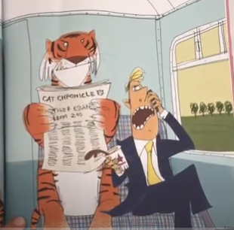
Don’t let a tiger on the train.

