2.2.21 Alternative maths

Count in 5s
Find the pattern on the hundred square by counting on 5 more each time. I have started it for you. You can use the fingers on one hand to keep track. What is the pattern?

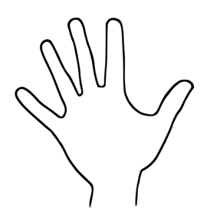
1,2,3,4,5… 6,7,8,9,10… 11,12,13,14,15…

Now: check your answers

The numbers always end in 5 or 0 when counting in 5s
.
5 10 15 20 25 30 35 40 45 50 55 60 …

Next: use your 5s to find out how many objects there are

5 10 15 ?

5 ? ? ? ?

