Maths- Ordering numbers
Use base 10 or the place value chart to show the place value of each of these three digit numbers. I have done one for you.
347 478 106 832 999 740
H | T | O
3 | 4 | 7
H | T | O
H | T | O
H | T | O
H | T | O
H | T | O

When ordering numbers we can do so from greatest to smallest or smallest to greatest.
If we order from smallest to greatest it is called ascending order.
If we order from greatest to smallest it is called descending order.

For example: Ascending order= 106,347,478,740,832,999

Descending order = 999,832,740,478,347,106
Have a go at the activities below by ordering the numbers in different ways. Remember to draw the base 10 or partition the number to help you if you need it.

1. Put these numbers in ascending order: 346 436 643 364 463 634

__________, ___________, ___________, ___________, ____________, ____________

2. Put these numbers in descending order: 592 952 259 529 925 295

__________, ___________, ___________, ___________, ____________, ____________

3. What is the greatest number you can make using these three digits? How do you know?
4 7 6

____________________

4. What is the smallest number you can make using these 3 digits? How do you know?
4 7 6

____________________

5. Write the numbers represented then put them in order from greatest to smallest (descending order).
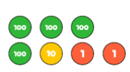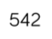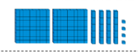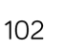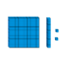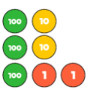

__________, ___________, ___________, ___________, ____________, ____________

6.

