How to do each exercise

Crunches

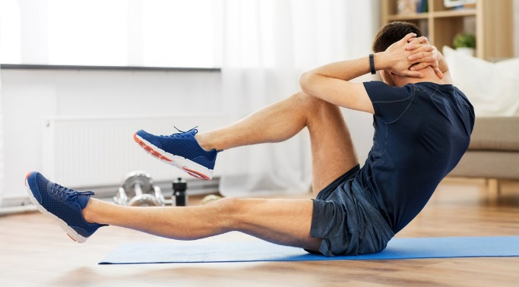

Lie on your back with your hands behind your head.

Lift your head and shoulders off the ground, as you do this bring your left knee to touch your right elbow.

Now do the same with your right knee. Repeat this ten times.

Plank

Keep your palms on the floor next to your shoulders and your feet flexed with the bottoms of your toes on the floor.

Take a deep breath and press up into a push-up. Your body should make a straight line from your heels to the top of your head. Pull your stomach in and hold this for two minutes.

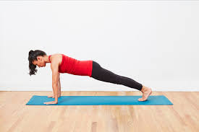

Lunges

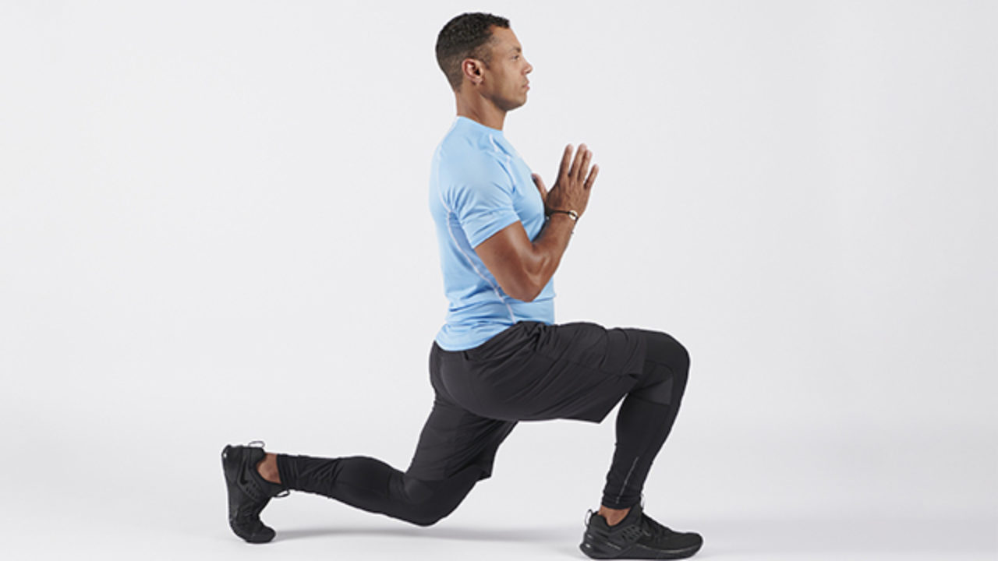

1. Start by standing up tall.
2. Step forward with one foot until your leg reaches a 90-degree angle. ...
3. Lift your front **lunging** leg to return to the starting position.
4. Repeat 10 to 12 reps on one leg, or switch off between legs until you've completed 10 on each leg.