Alternative geography- European landmarks

Draw a line to match the European landmark to its location and name. I have done one for you.

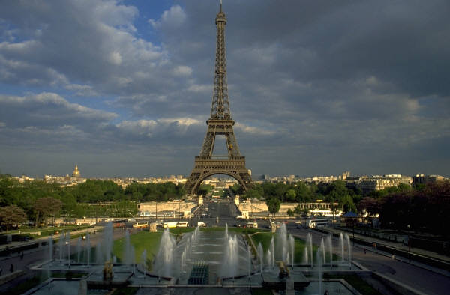 Tower of Pisa England

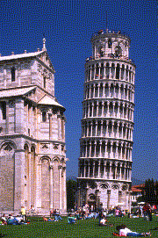 Tower Bridge France

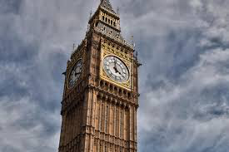 Eiffel Tower England

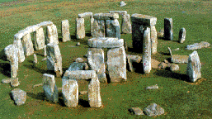 The colosseum Italy

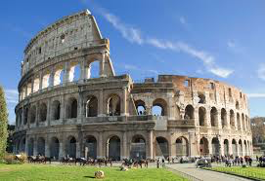 Big Ben Italy

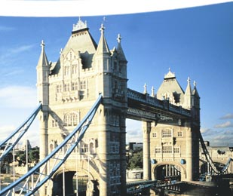 Stonehenge England

