22.1.21 To explore changes within living memory
Key words: past (what has already happened), present (happening today, now), changes (what is the same and what is different)

Use the images from the present and the past to play Spot the Difference. What has changed over time? Challenge if you are confident: can you find three things that are the same and three things that are different?

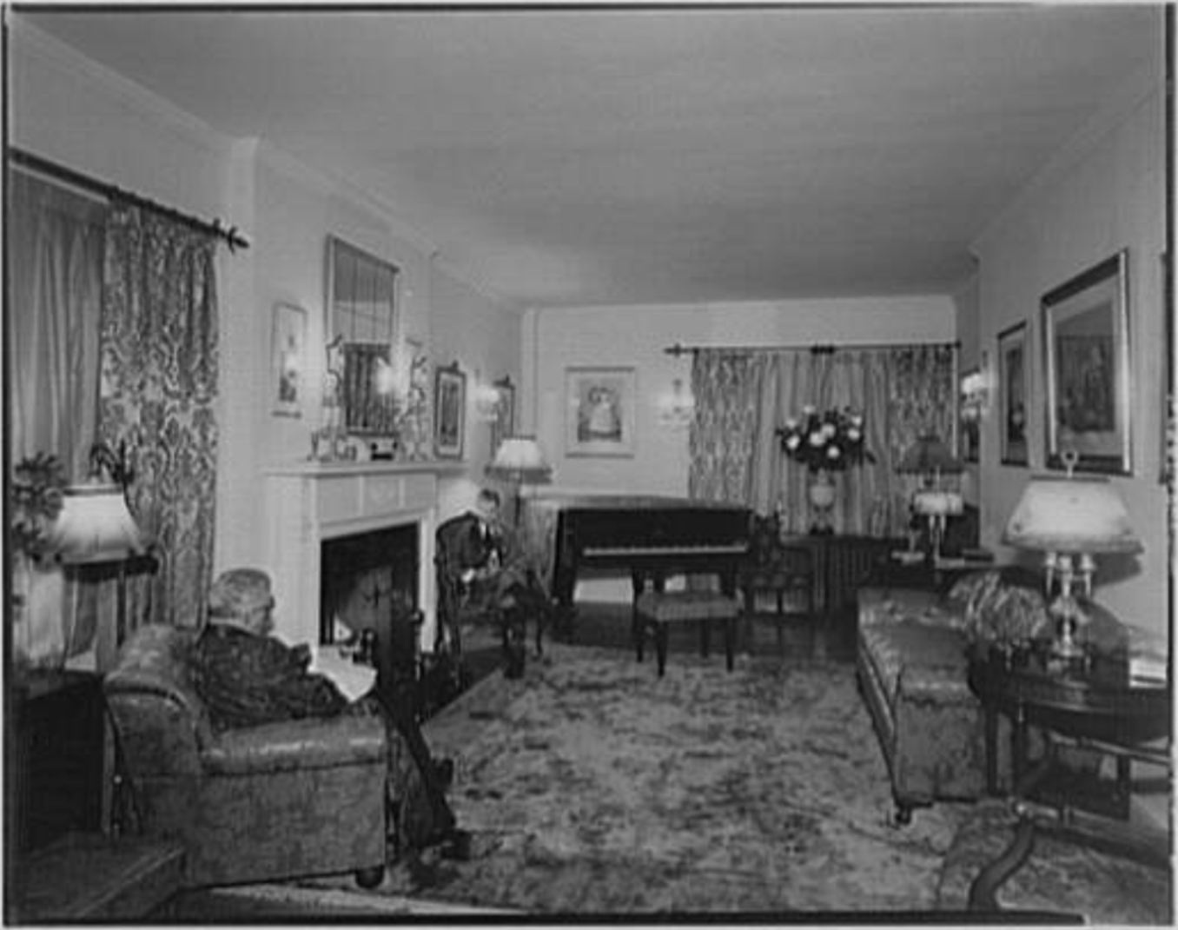

Same Different
______________________________________ ______________________________________

______________________________________ ______________________________________

______________________________________ ______________________________________

______________________________________ ______________________________________
A living room in the past
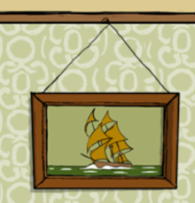
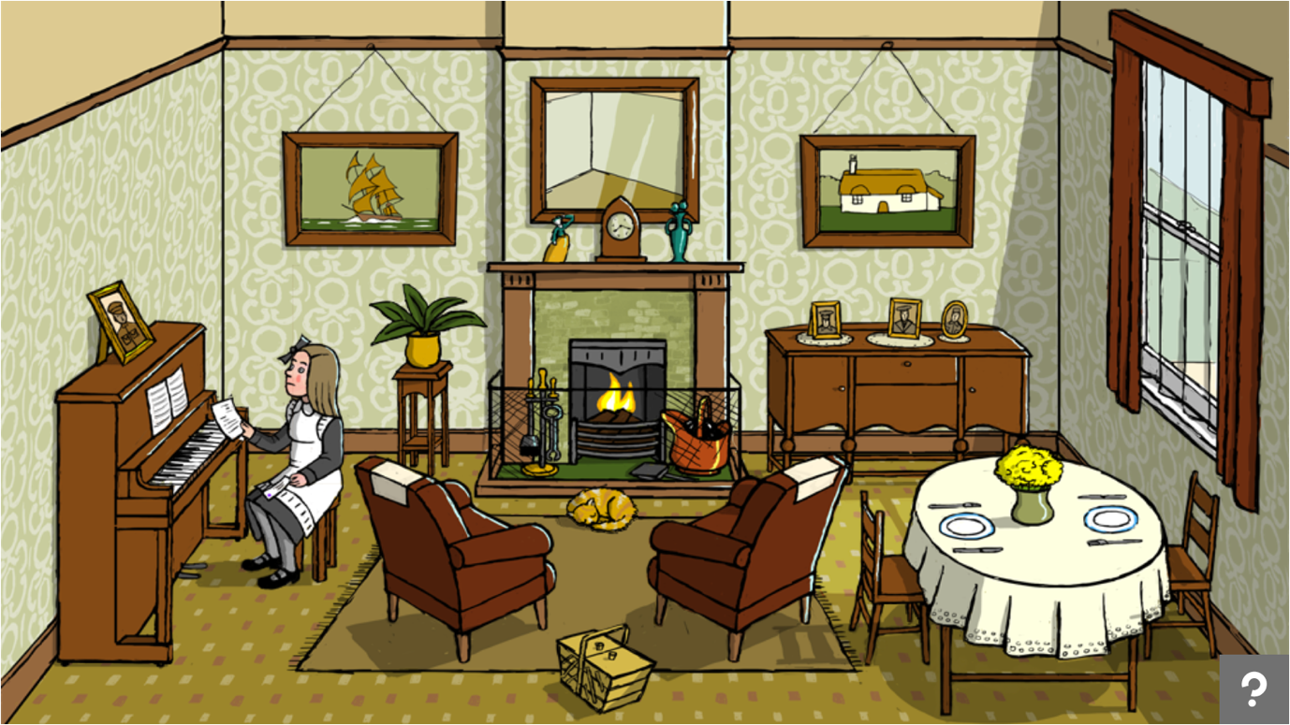
Pictures on the wall
People in the past used paintings or pictures to make their houses feel homely.

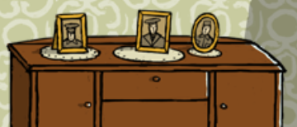
Photographs
It was unusual (not normal) to have lots of photographs as it cost a lot of money and normal people would not have a camera.
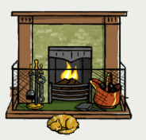
Fireplace
This was the only source of heating 100 years ago and burned wooden logs or coal.

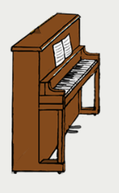
Piano
Not everyone had a radio at the time so this was the only way to listen to music. It was also something to do.

