Orange and yellow
Read the green words then draw the dots and dashes for the sounds. I have done one for you.
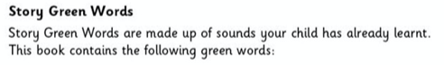
chicken Grandad cook cooked

good book look

