Maths – Number bonds to 10
Can you fill in the missing numbers to make the number bonds to 10? Use the number line and the Numicon below to help you.

1 + ___ = 10 6 + ___ = 10

2 + ___ = 10 7 + ___ = 10

3 + ___ = 10 8 + ___ = 10

4 + ___ = 10 9 + ___ = 10

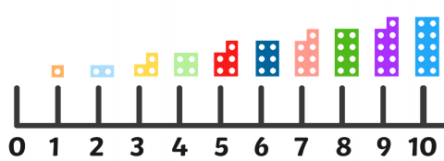
5 + ___ = 10 10 + ___ = 10

