To develop my knowledge of South-East England
- Can you find Dover on the map? | - Have a look at these this picture  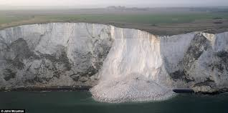  What can you see?  What do you think has happened?

