To explain my ideas using the text

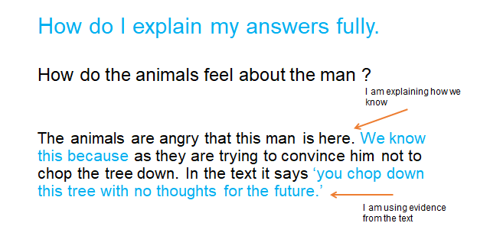

Why do the animals think the world will be destroyed?

How do they think they will stop him?

