Art
Learning intention: to evaluate a piece of art.
You are going to be an art critic and evaluate a piece of art.
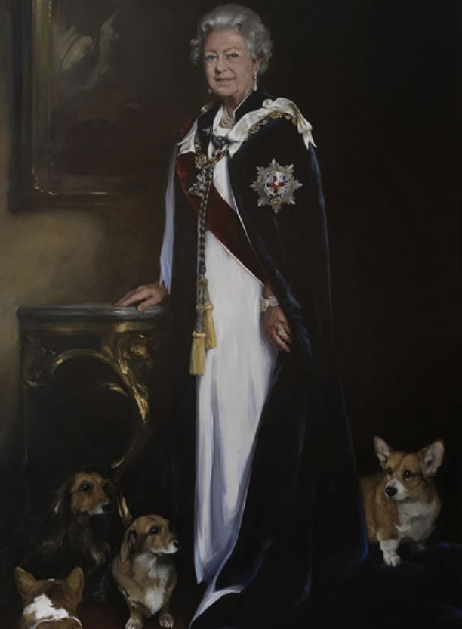
What do you see?

What do you like about this piece of art?

What colours has Nicky Philips used?

How does it make you feel?

If you were the artist, what would you improve if you were doing this again?

What is Nicky Philips really good at?

