One More
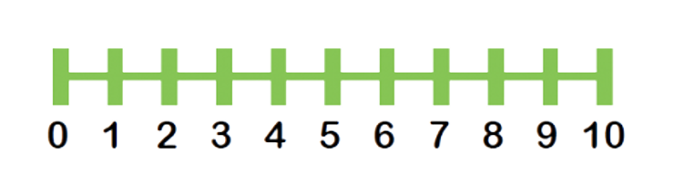`
What is one more than…

Remember, 1 more is the same as adding 1. Draw shapes to help you if you need to.

Example: 1 more than 4 is 5

3

6

8

2

1

0

5

