Maths

LO: To calculate perimeter

Can you draw 4 different shapes which all have a perimeter of 20cm?

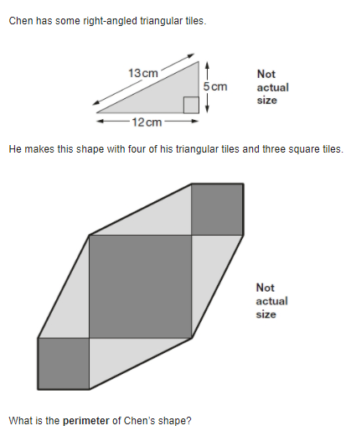

These two shapes have the same perimeter. The length of each side of the hexagon is 8cm. What is the length of each side of the square? 