Blue/grey
Try reading these words. Which ones are real and which ones are nonsense (alien) words?
Tick () the real words and draw an alien (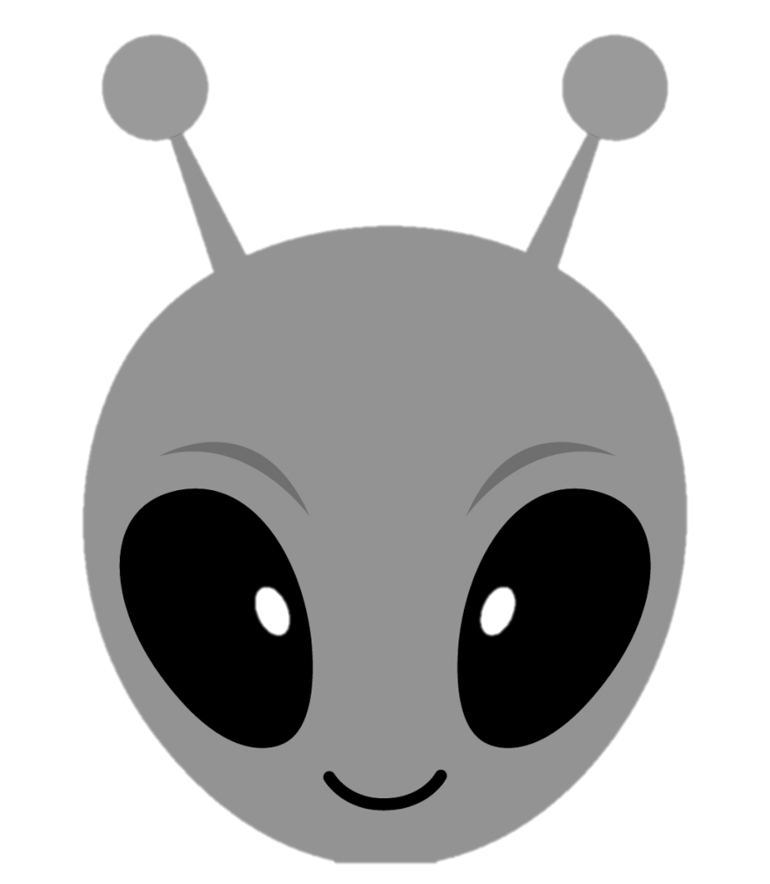) for the nonesense words.
