Maths - To compare and order money

Read what the question is asking you carefully. I will give you a hint, there are 12 answers to find in total.

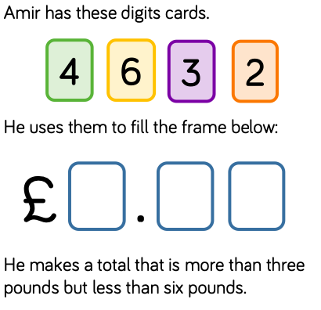

Task 1) Can you work out all the different amounts he can make using the information given?

£………………… £………………… £…………………

£………………… £………………… £…………………

£………………… £………………… £…………………

£………………… £………………… £…………………

Task 2) Can you order your amounts, smallest to largest?

