Learning Intention - To explore angles in triangles

Use the information from the PowerPoint to, compare and classify triangles based on their properties and sizes.

True or false.
An equilateral triangle has different lengths.

True or false
An isosceles triangle has three sides all the same length.

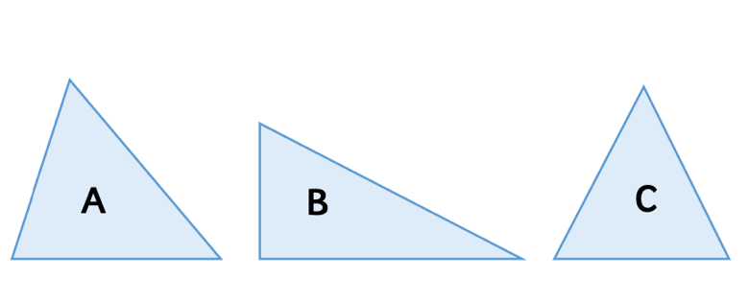

Which triangle is the scalene triangle?
How do you know?

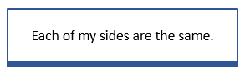What type of triangle am I?

