History
Can you draw in the boxes things that you would find in a house in the past and a house from now?
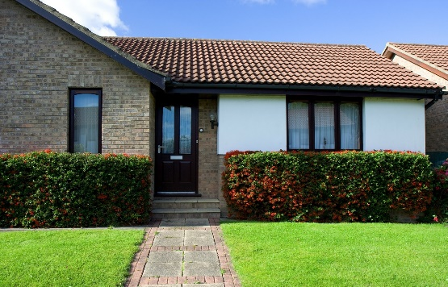  A house from now | 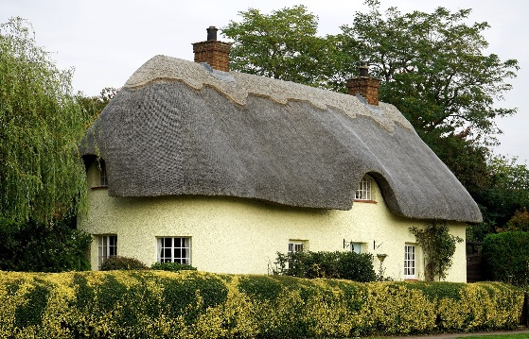  A house in the past

