Maths Alternative 2
To compare and order money

Have a look at this question carefully then answer the questions below.

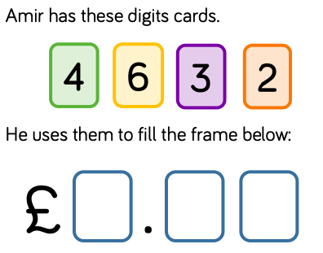

Task 1) Can you make an amount more than 2 pounds and less than 3 pounds?

Task 2) Can you make an amount more than 3 pounds and less than 4 pounds?
Task 3) Can you make an amount more than 6 pounds?
Task 4) What is the smallest total you can make?
Task 5) What is the largest total you can make?

