Learning intention: to talk about a story.
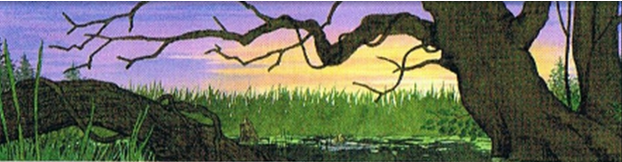
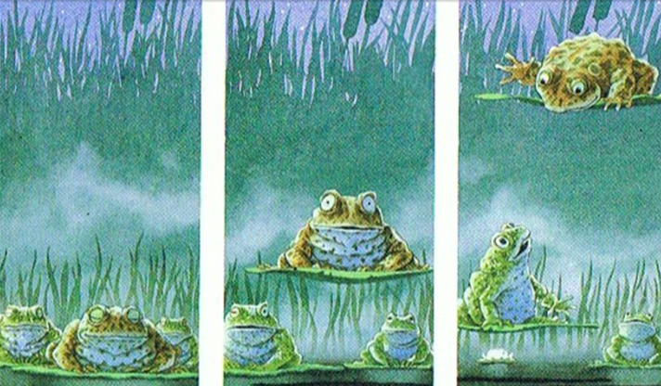
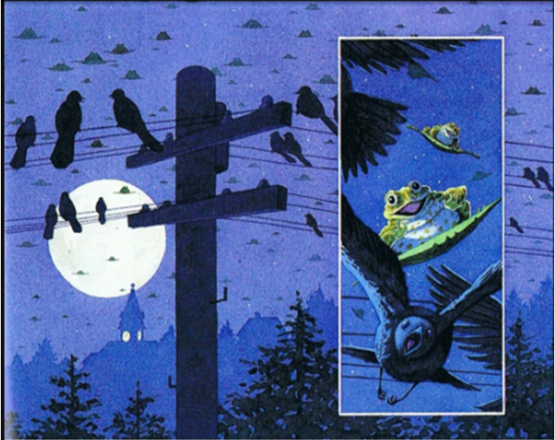
Looking at the pictures, can you talk or write about what is going on in the story?
Think about the following questions:
What is happening?
Who is in the story?
Where is the story set? When is the story happening?
Why do you think it is happening?
How do you think it is happening?

