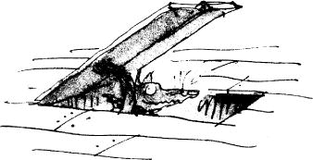
English alternative 1- Write a story
Today you are going to write your story, continuing on from chapter 10.
Have a look at your story map from yesterday and discuss with somebody at home what your story is going to include. Use this picture to help you.
Things to include:
- Rehearsal- Practise saying the sentence before writing it.
- Punctuation- Full stops, capital letters and inverted commas (speech marks).
- Conjunctions- Remember a conjunction is a word which joins two clauses together (and, because, so, but, even though).
- Write in the 3rd person- Remember to write the story about other people, not yourself or the reader (using words such as they, he, she, their and the character’s names).
- Speech-Include some speech in your writing, remember to use speech marks!
- Adjectives- Describing words.
- Use your imagination!
- Re read your work as you go to check it is your best writing!

